CECS 328 Midterm 1 Materials to study for the Final: Insertion Sort, Merge Sort, Finding MaxSubArray. Runtime and order of magnitude/growth Big-O, Little-O, Big Omega, Little Omega, Theta. Finding magnitude by a given snippet of code. Extended Master Theorem. Finding upper bound, lower bound, etc. Proof by induction, Proofs regarding showing order of magnitude/growth (e.g.: Training Problems 3 Problems 1 and 2). Recursion Trees
Chapter 2 Getting Started
Section 2.1 – Insertion Sort
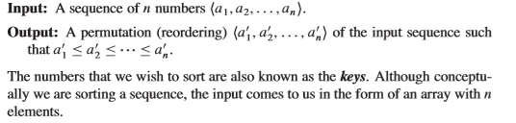
Be aware of the starting index (0 is for programming, 1 is for the textbook).
Insertion Sort Visualizer:
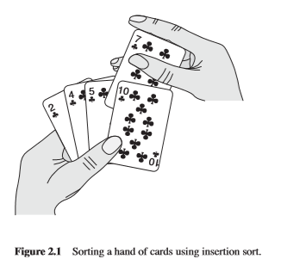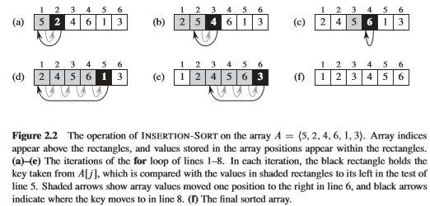
Insertion Sort Details:
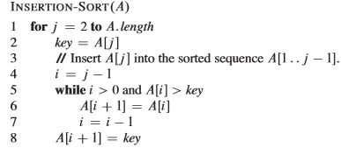
Advantages of Insertion Sort:
*Easy to implement. Good for small input size.
*Best Case Scenario: Input array already sorted c₁n AKA O(n) runtime.
*Sorts in place: Only requires a constant amount of additional Memory space of O(1).
Stable: Numbers with the same value appear in the output array in the same order as input array.
Disadvantages of Insertion Sort:
*Not efficient, c₁n² AKA O(n²) runtime.
Loop Invariant:
*Predicate (condition) that must hold true for every iteration of the loop/algorithm.
*Used to prove correctness of an algorithm.
*Helps us why an algorithm is correct.
Initialization of Insertion Sort:
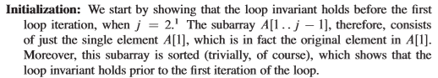
Maintenance of Insertion Sort:
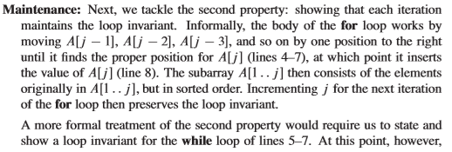
Termination of Insertion Sort:
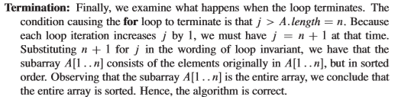

Section 2.2 – Analyzing Algorithms
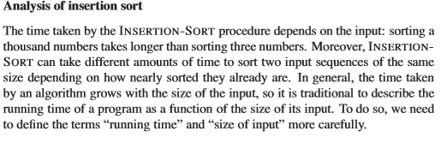
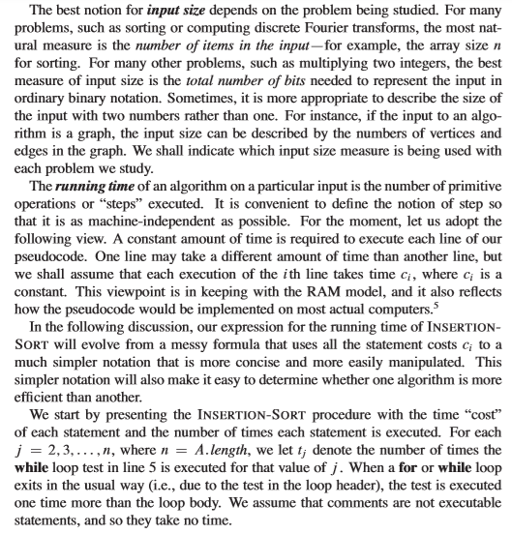
Cost of Insertion Sort:
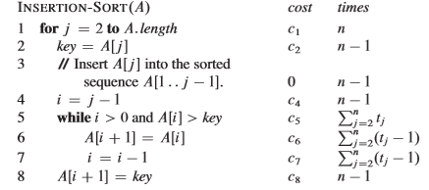
*t_{j} is the number of times the while loop is executed for that value of j.

Cost of Insertion Sort Overview:
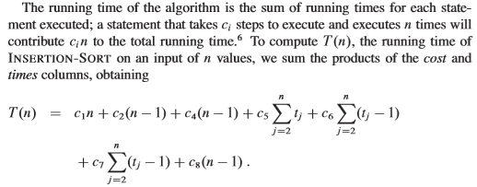
Best Case Analysis of Insertion Sort:
*Best case occurs when we get to skip lines 6 and 7 because the while loop did not go through.
Input array is already sorted.
Contents of the while loop doesn’t get executed because A[i] isn’t greater than the key.
T(n) used to denote runtime.
*Arithmetic Series:
$\sum_{j = 2}^{n}{j}$= 2 + 3 + … + n = $\frac{n (n + 1)}{2}$ – 1

$\sum_{j = 2}^{n}{1 }$= 1 + 1 + … + 1 = n – 1
*If you have j = 2, then n – 1.
Best Case Insertion Sort Cost
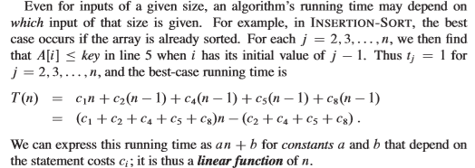
*Ѳ(n) order of growth.

Worst case of Insertion Sort Analysis:
Input array is in reverse sorted order.
Insertion Sort Summations
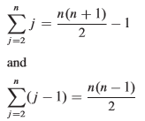
Worst Case Insertion Sort Cost
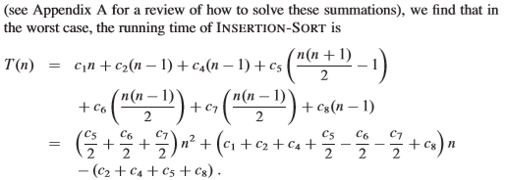
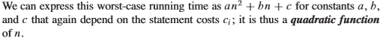
*Ѳ(n²) order of growth.
*NOTE: Average case is nearly the same as Worst Case. Also, the Best case does not occur much frequently as the Worst Case, that is why most people will tell you the runtime of its worst case.
Order Growth:
*Use abstraction.
*Drop the lower order terms.
*Ignore the constant coefficient of the leading terms (negative is part of a constant!)
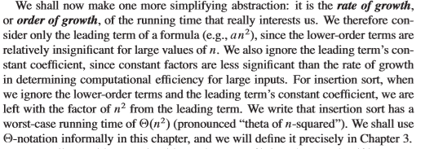
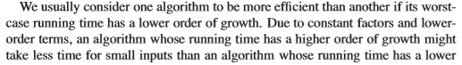

Section 2.3 – Designing Algorithms
*Algorithm Design: Incremental vs Divide and Conquer
Concept of Divide and Conquer:
1. Divide the problem into a number of subproblems.
2. Conquer the subproblems by solving them recursively.
3. Combine the sub problem solutions to give a solution to the original problems.
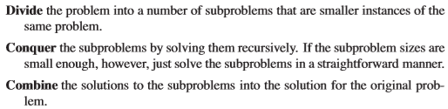
Mergesort:
*When the length of the array is odd, either floor or ceil, then stay consistent (divider).
-Recursively splits into every elements become singletons (elements by themselves) and then merges as a single sorted array.
Figure 2.3
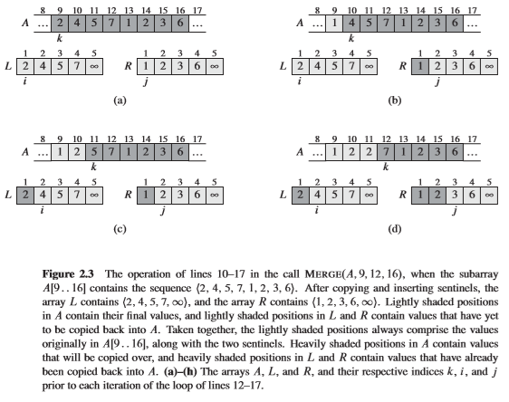
Mergesort Algorithm:
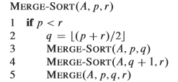

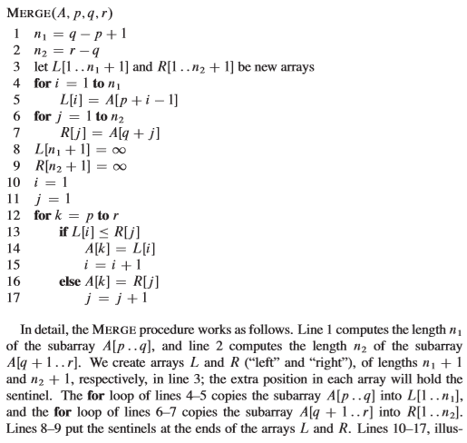
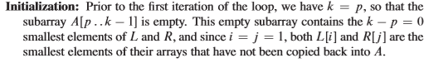
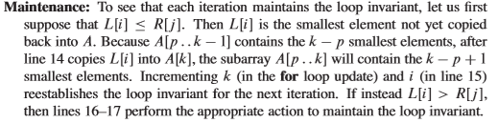
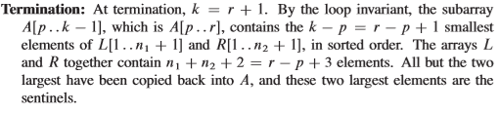
Figure 2.4
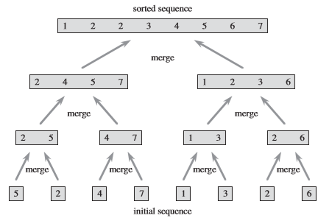
Mergesort on A = <5, 2, 4, 7, 1, 3, 2, 6>
Properties of Mergesort:
*Stable
*Not in place
*Space Complexity is Ѳ(n) due to inconsistencies: array size is odd, so it needs a divider!
Analysis of Mergesort:
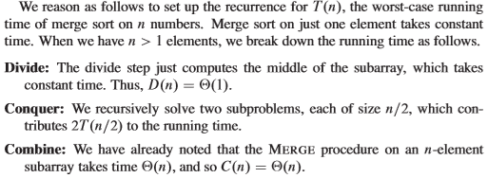
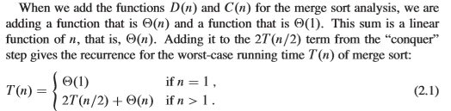

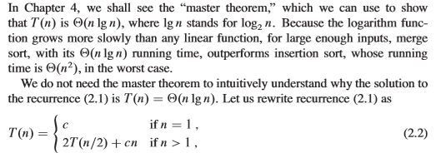

To find the runtime of mergesort, we use a recursion tree.
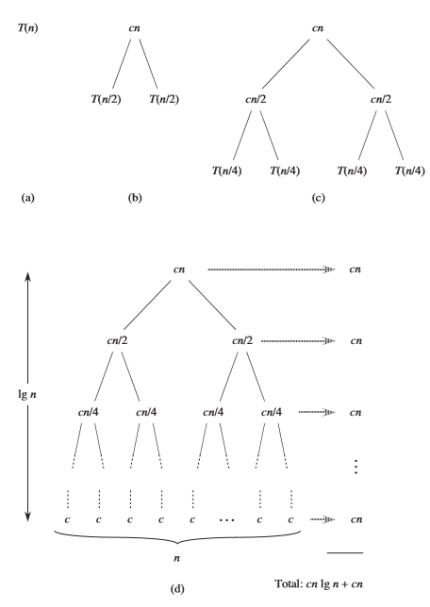
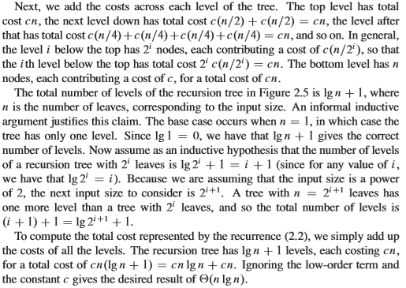
T(n) = 2T ($\frac{n}{2})$+ Ѳ(n) = cn (lg n + 1) + Ѳ(n) = cn (lg n + 1) + Ѳ(n)
Drop low ordered terms and leading term’s coefficient, you get
T(n) = Ѳ (n lg n) for n > 1
Cn is the cost per level of the tree and there lg n + 1 levels.
Chapter 3 – Growth of Functions
Section 3.1 Asymptotic Notation
The way to think of asymptotic notation is to think of as a function is to convert the algorithm to a function, then find asymptotic bound of it.
One Example is to look at Insertion Sort’s Best case and is represented by the function an + b, from there it’s Ѳ(n).
Another example is to look at Insertion Sort’s Worst case and is represented by the function an² + bn + c from there it’s Ѳ(n²).
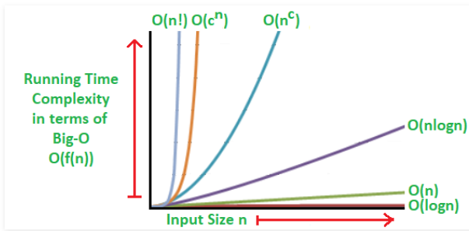

Order of Functions:
* Ѳ(1) < Ѳ(log n) < Ѳ(n) < Ѳ(n log n) < Ѳ(n²) < Ѳ(n³) < Ѳ(n⁴) < Ѳ(n^{n}) < Ѳ(n!)
Theta Ѳ Notation:
*Means that it’s asymptotically tightly bound.
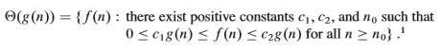
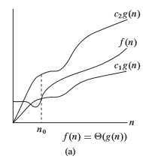
*In order for Ѳ to hold true, you must prove that it holds for Big Omega(Ω) and Big O(O).
*As long as you can find a number (constant) that can hold for both sides of the inequality (both Big Omega and Big O), then it holds for Ѳ (analyze both sides).
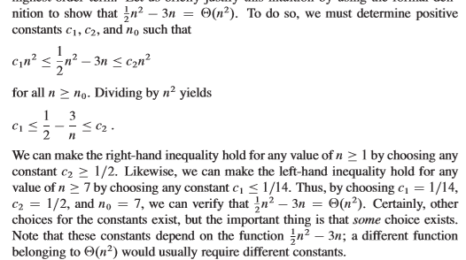
Big Omega Ω Notation:
*Means it’s asymptotically lower bound.
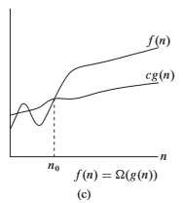
Big O O Notation:
*Means it’s asymptotically upper bound.
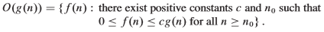
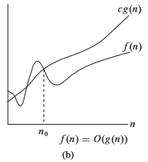

Litte O o Notation:
*Similar to Big O O, but it is loose upper bound.
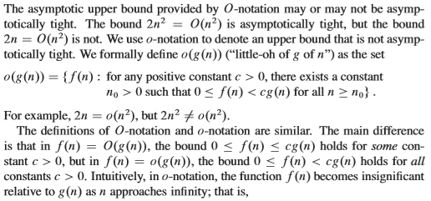
Here are some examples whereas it holds for Big O O, but does not hold for Little O o
- 2n² != o(n²)
- x² = O(x² + x)
- x² = O(200x²)
*NOTE: Just because it holds for Big O O, it does not mean that it will hold for Little O o.
Here are some examples whereas it holds true for Little O o and this will also hold for Big O O.
- x² = o(x³)
- x² = o(x!)
- x = o(x log x)
*NOTE: *NOTE: If it holds for Little O o, then it also hold for Big O O.
Little Omega ω Notation:
*Similar to Big Omega Ω, but it is loose lower bound.
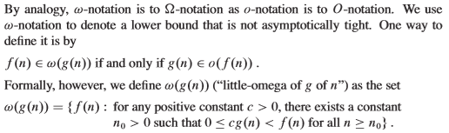
*NOTE: Just because it holds for Big Omega Ω, it does not mean that it will hold for Little Omega ω.
Here are some examples whereas it holds for Big Omega Ω, but does not hold for Little Omega ω
- x² = Ω(x²)
- x² = Ω(x² + x)
- x² = Ω(200x²)

Here are some examples whereas it holds true for Little Omega ω and this will also hold for Big Omega Ω.
- x² = ω(x)
- x! = ω(x²)
- x = ω(lg x)
*NOTE: If it holds for Little Omega ω, then it also hold for Big Omega Ω.
*f(n) is the function generated from the algorithm.
*g(n) is the bounds (e.g.: when you drop the low ordered terms, and the leading term’s coefficients).
Limits:
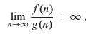
Determining the runtime from a snippet of code:
*Rules – Do not guess by the looks of the code!
Actually write out the pattern and code by hand. Once you determine the pattern, confirm the pattern and then determine which rule (arithmetic series), etc. to use to determine runtime.
The last for loop execution is when i reaches n. Let x be the last iteration of the for loop. Solve for x.
*Arithmetic Series: p = 1 + 2 + … + k = $\frac{k (k + 1)}{2}$ > n
Section 3.2 - Standard notations and Common Functions
Monotonicity:
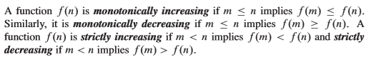
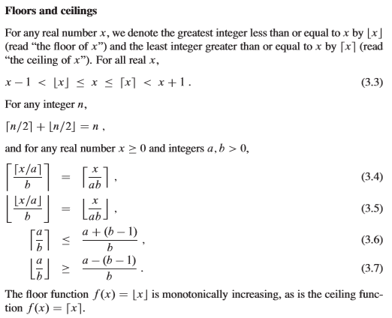
Exponentials:
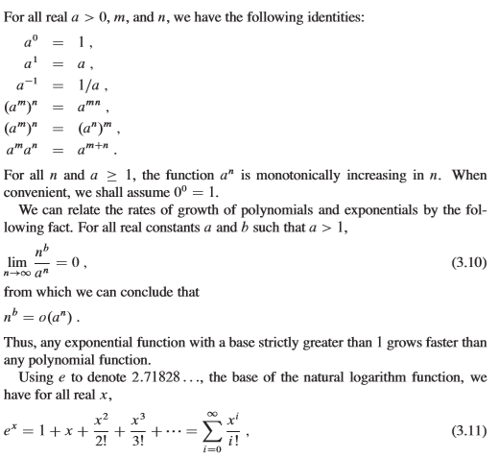

Logarithms:
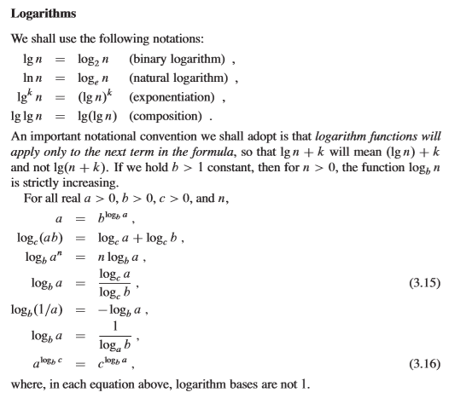
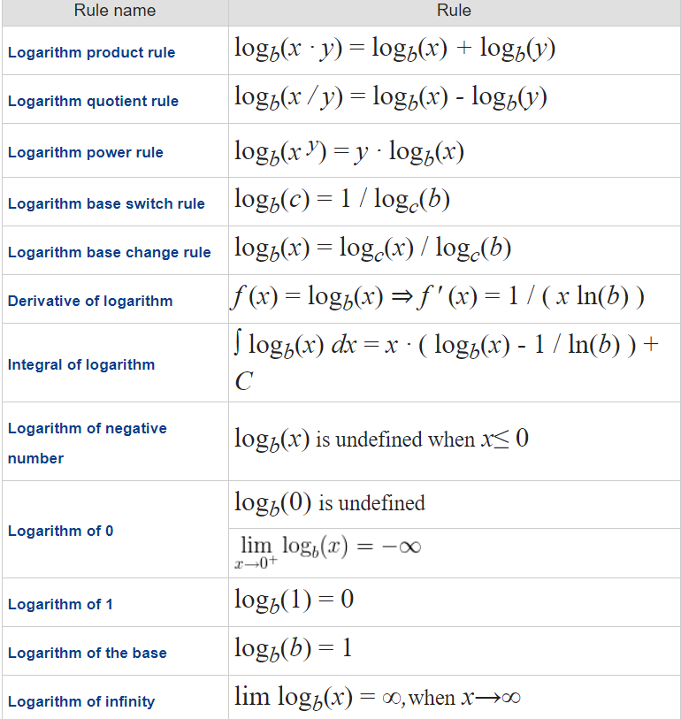

Chapter 4 – Divide and Conquer
Section 4.1 – The Maximum SubArray Problem
*The task of finding the contiguous subarray within a one – dimensional array A[1 … n] of numbers which has the largest sum.
Overview
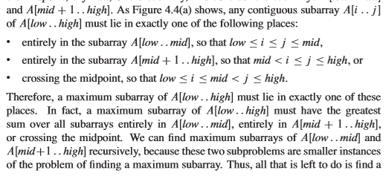
FMS(A, low, mid)
FMS(A, mid + 1, high)
FMCS(A, low, mid, high)
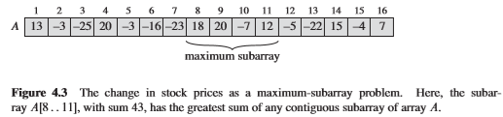
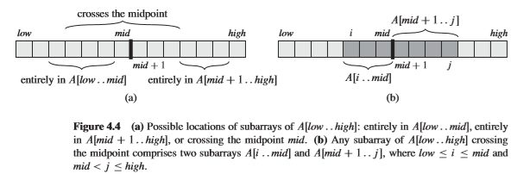
FMS = Finding Max SubArray
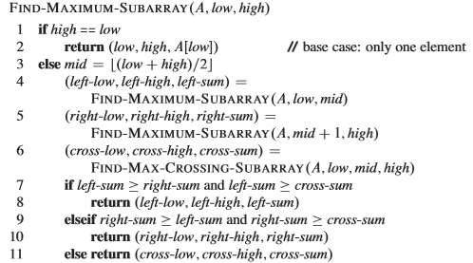
FMCS = Find Max Crossing SubArray
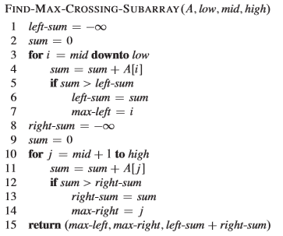
*Time Consuming!
High and Low index will also be returned.
Section 4.2 – The Substitution Method
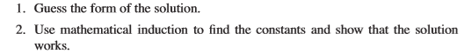
(HARD!)
*We need to snow n >= n₀ for n_{o} that we get to choose.
*Boundary Case: Very first case it passes!
*Continue testing boundary cases until you start depending on a past boundary.
Calculating a log base of a number: ex log₃ of 27 = 3. On calculator, $\frac{log number intended}{log base number}$

Section 4.3 Extended Master Theorem
More portable (can be applied to more recurrences)
Extended Master Theorem Form:
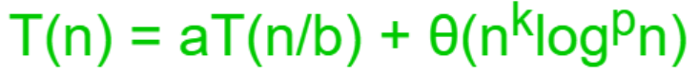
*NOTE: log^{p} n = (log n)^{p},
b^{k}
(log n)⁰ = 1
n log⁻¹ n = $\frac{n}{log n}$
*Properties of Extended Master Theorem:
a >= 1, b > 1, k >= 0, and p is a real number
*k is associates with n
*p associates with log n
*a associates with aT
*b associates with $\frac{n}{b}$
*If T(n) is monotone such as T(n) = cos n or T(n) is polynomial or one of the properties of the extended master theorem does not follow, then it cannot be used.
Extended Master Theorem Formula: If b = 1, then extended master theorem can’t be used!
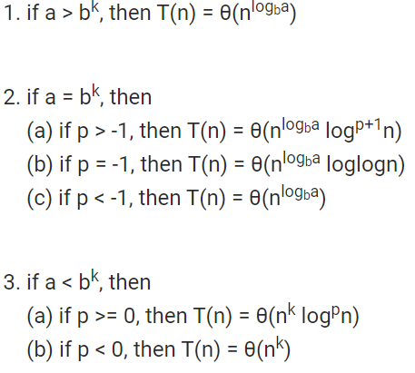
Example of Extended Master Theorem:
Example 1: T(n)=2T ($\frac{n}{2}$) + n log n
a = 2, 2 >= 1 YES
b = 2, 2 > 1 YES
k = 1, 1 >= 0 YES
p = 1
b^{k} = 2¹ = 2
Case 1: Is a = 2 > b^{k} = 2, NO
Case 2: Is a = 2 = b^{k} = 2, YES
Case 2a: Is p = 1 > -1, YES, so T(n) = Ѳ(n^{log}_{b}ª log ^{p+ 1} n) = Ѳ(n^{log}₂² log ¹⁺ ¹ n) = Ѳ(n log ²n)
log₂2 = lg 2 = 1
Example 2: T(n) = 2T ($\frac{n}{2})$ + $\frac{n}{log n}$
a = 2, 2 >= 1, YES
b = 2, 2 > 1, YES
k = 1, 1 > 0, YES
p = -1
n log⁻¹ n = $\frac{n}{log n}$
b^{k} = 2¹ = 2
Case 1: Is a = 2 > b^{k} = 2, NO
Case 2: Is a = 2 = b^{k} = 2, YES
Case 2a: Is p = -1 > -1, NO
Case 2b: Is p = -1 = -1, YES, so T(n) = Ѳ(n^{log}_{b}ª log log n) = Ѳ(n^{log}₂² log log n) = Ѳ(n log log n)
log₂2 = lg 2 = 1

Section 4.4 – Recursion Trees
*The most time consuming way to solve a recurrence.
More difficult than Extended Master Theorem.
Useful for visualizing what happens when a recurrence is iterated. It diagrams the tree of recursive calls and the amount of work done at each call.
Use abstraction; thus disregarding the floor as well as the ceil.
*Recurrence Form: T(n) = aT ($\frac{n}{b})$ + n
*a is the number of branches in each recursion tree for each node except for leaves.
*b represents the number of diving the subproblem size during each iteration.
*n represents the input array format, recursion tree starts at input array format (top level).
* Plugging in the $(\frac{n}{b})$ in its own recurrence will find the subproblem size for each level.
*Add up the sum of each level (adds across) and save those results in order to put it in the geometric series formula.
*At the bottom of the recursion tree, when you hit the 1, it means that you hit the base case.
*You must find the pattern of the subproblem sizes before finding the depth of the tree.
*In order to find the depth of the tree, set 1 = the pattern of the subproblem size, then solve for x.
Solving for x get you the depth of your tree.
Geometric Series Formula Appendix A Equation A.5:
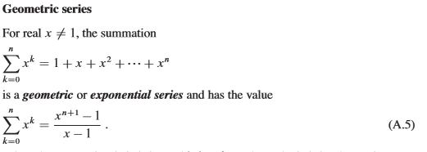
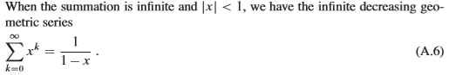

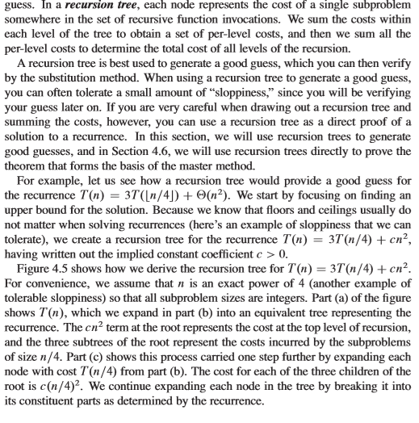

Here we have a recurrence of T(n) = 3T ($\frac{n}{4}$) + cn²
a = 3, we will have 3 branches in each recursion tree for each node except leaves
b = 4, we will dividing the problem size by 4 in each iteration
input array format = cn², we will see that cn² will be at the beginning of the recursion tree.

Figure 4.5 Diagram:
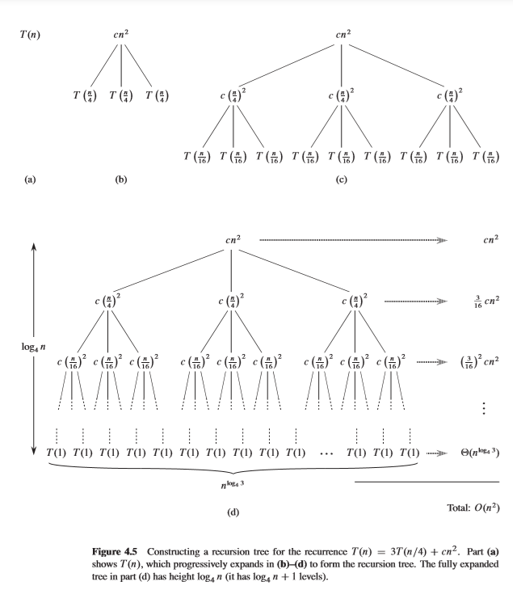
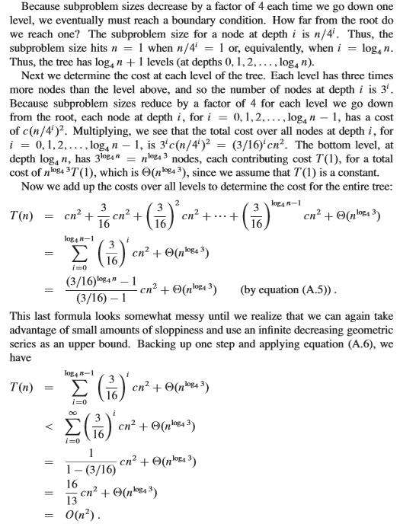

Sorting and Searching Algorithms
Linear Search:
*Procedure: Iterative/sequential search until the element is found or not found.
Then returns the position of the element is at. If element is not found, return NIL.
Linear Search Algorithm:
Linear Search(A, v)
i = 0
for i to A.length
if v = A[i]
return i
i = i + 1
return NIL
Best Case of Linear Search: O(1) because linear search makes one comparison and immediately returns the value without looking anywhere else.

Average/Worst Case of Linear Search: O(n) because linear search makes n comparisons and the target may be found in the middle or maybe at the end of the array. Worst case, if the target is not found, then returns NIL.
*NOTE: If there are duplicates, in linear search, the algorithm returns the position of the first copy that was found.

Binary Search:
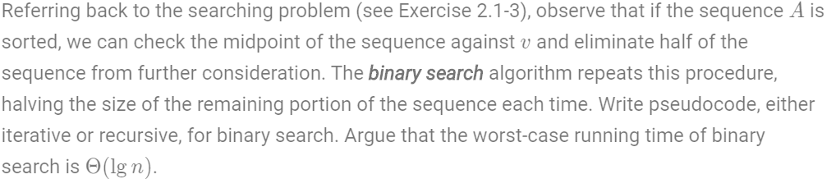
*Procedure: Search a sorted array by repeatedly dividing the search interval in half. Begin with an interval covering the whole array. If the value of the search key is less than the item in the middle of the interval, narrow the interval to the lower half. Otherwise narrow it to the upper half. Repeatedly check until the value is found, or the interval is empty.
Iterative Binary Search Algorithm:
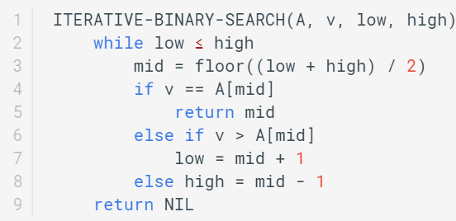

Recursive Binary Search Algorithm:
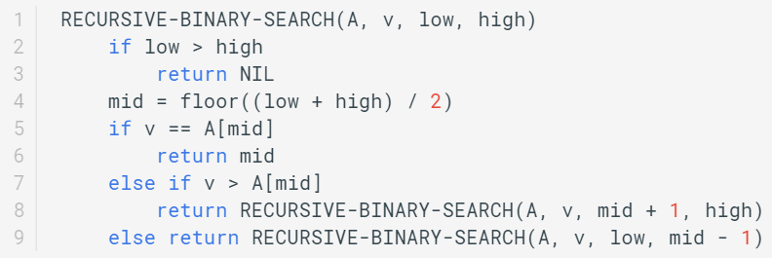
*NOTE: Before operating Binary Search, the array must be sorted.
Binary Search Best Case: O(1) because the element you are searching for is the middle element of the list/array because in that case you will get the desired result in a single go.
Binary Search Average/Worst Case: O(lg n) because the element is found by ranging the array in half or the element does not exist in the array at all.
Thus, Binary Search is more efficient than linear search.
Bubble Sort:
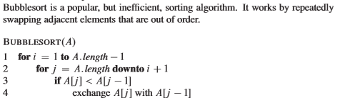
BubbleSort Best Case: O(n) when the array is already sorted.
BubbleSort Average/Worst Case: O(n²) because some elements are not sorted or sorted in reverse order and will do exchanges with adjacent elements.

